Human Eye - 01
CLASS 10 - SCIENCE

 | Section A
 | Question No. 1 to 4 are based on the given text. Read the text carefully and answer the questions: Atmospheric refraction is the phenomenon of bending of light on passing through earth’s atmosphere. As we move above the surface of earth, density of air goes on decreasing. Local conditions like temperature etc. also affect the optical density of earth’s atmosphere. On account of atmospheric refraction, stars seen appear higher than they actual are; advanced sunrise; delayed sunset, oval appearance of the sun at sunrise and sunset; stars twinkle, planets do not. | [4]
1 | How does atmospheric refraction affect the apparent length of the day?
2 | Why does Sun appear slightly oval shaped at morning and evening?
3 | Why do the stars twinkle but planets don’t?
4 | What color does the sky appear in the absence of an atmosphere?
 | Question No. 5 to 8 are based on the given text. Read the text carefully and answer the questions: The spreading of light by the air molecules is called the scattering of light. The light having the least wavelength scatters more. The sun appears red at sunrise and sunset, the appearance of the blue sky is due to the scattering of light. The colour of the scattered light depends on the size of the particles. The smaller the molecules in the atmosphere scatter smaller the wavelengths of light. The amount of scattering of light depends on the wavelength of light. When light from the sun enters the earth’s atmosphere, it gets scattered by the dust particles and air molecules present in the atmosphere. The path of sunlight entering in the dark room through a fine hole is seen because of the scattering of the sunlight by the dust particles present in its path inside the room. | [4]
5 | Does the color of Earth appear different to an astronaut in a spaceship?
6 | Why does the sky appear blue?
7 | Why at sunrise or sunset, the sun appears to be reddish white?
8 | Why is the red color selected for danger signal lights?
 | Section B
9 | Rainbow is formed due to a combination of?  - Refraction  - Absorption  - Dispersion  - Total internal reflection  a) A and B  b) A and C  c) A, C and D  d) A, B and C | [1]
10 | Which one of the following is the correct reason for twinkling of stars?  a) Scattering of starlight  b) Atmospheric reflection of starlight  c) Dispersion of starlight  d) Atmospheric refraction of starlight | [1]
11 | The phenomena of light involved in the formation of rainbow are  a) Refraction, dispersion and scattering.  b) Refraction, reflection and dispersion.  c) Refraction, dispersion and internal reflection.  d) Reflection, dispersion and total internal reflection. | [1]
12 | An old person is unable to see clearly nearby objects as well as distant object. To correct the vision, what kind of lens will he require?  a) Bifocal lens whose upper portion is concave lens and lower portion is convex lens  b) Concave lens  c) Bifocal lens whose upper portion is convex lens and lower portion is concave lens  d) Convex lens | [1]
13 | A prism ABC (with BC as base) is placed in different orientations. A narrow beam of white light is incident on the prism as shown in Figure(options). In which of the following cases, after dispersion, the third colour from the top corresponds to the colour of the sky?  a) 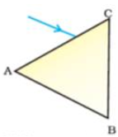  b) 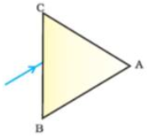  c) 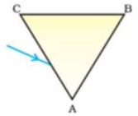  d) 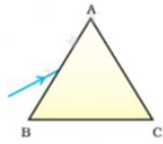 | [1]
14 | A person with a myopic eye cannot see objects beyond 1.4 m distinctly. The type of the corrective lens used to restore proper vision should be  a) A convex lens of focal length 1.4 m and power +0.71 D  b) A convex lens of focal length - 1.4 m and power - 0.71 D  c) A concave lens of focal length - 1.4 m and power - 0.71 D  d) A concave lens of focal length - 1.4 m and power +0.71 D | [1]
15 | Which is the correct condition for the total internal reflection to occur?  a) All of these  b) light should pass from rarer to denser medium  c) light should pass from denser to rarer medium  d) Critical angle should be greater than angle of incidence | [1]
16 | If a person can see a doll at the far distance, but he cannot have the newspaper in his hands. What lens should he wear to make correct his eyesight?  a) Concave lens  b) Prism  c) Convex lens  d) Bi - focal lens | [1]
17 | In human eye the part which allows light to enter into the eye is -  a) Pupil  b) Cornea  c) Retina  d) Eye lens | [1]
18 | The value of least distance of distinct vision for a normal human eye is ________.  a) 25 cm  b) 70 cm  c) 35 cm  d) 45 cm | [1]
19 | Which of the following phenomena of light are involved in the formation of a rainbow?  a) Reflection, refraction and dispersion  b) Dispersion, scattering and total internal reflection  c) Refraction, dispersion and total internal reflection  d) Refraction, dispersion and internal reflection | [1]
20 | Figures (a), (b), (c) and (d) respectively correspond to  - 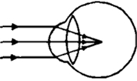  - 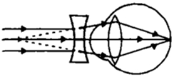  - 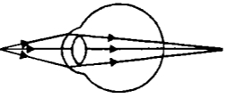  - 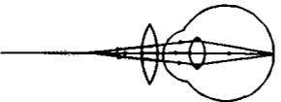  a) The short - sighted eye, the correction of short - sightedness, the long - sighted eye and the correction of long - sightedness  b) The long - sighted eye, the correction of shortsightedness, the short - sighted eye and the correction of long - sightedness  c) The short - sighted eye, the correction of long - sightedness, the long - sighted eye and the correction of short - sightedness  d) None of these | [1]
21 | What is the spectrum?  a) None of these  b) The band of 5 colours.  c) The band of 6 colours.  d) The band of 7 colours. | [1]
22 | The lens of the eye can become thicker and thinner. Why is this flexibility useful?  a) The lens is not likely to break.  b) The lens allows the eye to focus on far objects as well as near objects.  c) The eye can move up, down, left and right.  d) The lens can allow varying amounts of light to enter the eye. | [1]
23 | What is the value of refractive index of the medium if the critical angle of incidence in a denser – rarer inter face is equal to 45$​^{o}$ ?  a) 3.25  b) 2.0  c) 1.414  d) 2.414 | [1]
24 | The amount of light entering the human eye is controlled by:  a) Pupil  b) Cornea  c) Iris  d) Ciliary muscles | [1]
25 | The light - sensitive cell present on the retina and is sensitive to the intensity of light is:  a) Cones  b) Rods  c) Both rods and cones  d) None of these | [1]
26 | An optician while testing the eyes find the vision of a patient to be$\frac{6}{9}$ . By this he means that  a) The person can read letters from 9 m which the normal eye can read from 6 m.  b) The person can read letters from 6 m which the normal eye can read from 9 m  c) The person can read the letters of 9 inches from 6 m  d) The person can read the letters of 6 inches from a distance 9 m | [1]
27 | A passenger in an aeroplane  a) Shall never see a secondary rainbow  b) Shall never see a rainbow  c) May see a primary and a secondary rainbow as concentric arcs  d) May see a primary and a secondary rainbow as concentric circles | [1]
28 | Two equilateral prisms are arranged as shown in diagram. 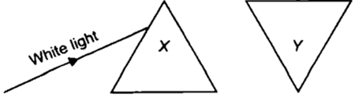  Statement 1 : If white light is incident on prism X, then the ray of light which emerges out of the prism Y will be white light. Statement 2 : Prism Y recombines the seven colours.  a) Both statements 1 and 2 are true but statement 2 is not the correct explanation of statement 1.  b) Statement 1 is true but statement 2 is false.  c) Statement 1 is false but statement 2 is true.  d) Both statements 1 and 2 are true and statement 2 is the correct explanation of statement 1. | [1]
29 | Match the column I with column II and select the correct option from the codes given here. 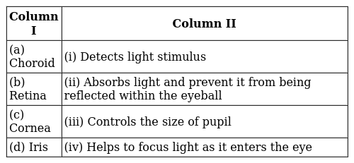  a) (a) - (iii), (b) - (iv), (c) - (i), (d) - (ii)  b) (a) - (ii), (b) - (iii), (c) - (iv), (d) - (i)  c) (a) - (ii), (b) - (i), (c) - (iv),(d) - (iii)  d) (a) - (i), (b) - (ii), (c) - (iii), (d) - (iv) | [1]
30 | Statement 1: A normal human eye can clearly see all the objects at a distance less than or greater than 25 m. Statement 2: The human eye has the capacity to suitably adjust the focal length of its lens to a certain extent.  a) Statement 1 is true but statement 2 is false.  b) Statement 1 is true but statement 2 is false.  c) Both statements 1 and 2 are true and statement 2 is the correct explanation of statement 1.  d) Both statements 1 and 2 are true but statement 2 is not the correct explanation of statement 1. | [1]
31 | A prism ABC (with BC as base) is placed in different orientations. A narrow beam of white light is incident on the prism as shown in figure.In which of the following cases, after dispersion the third colour from the top corresponds to the colour of the sky? 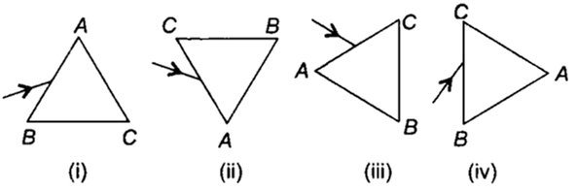  a) Figure (ii)  b) Figure (iii)  c) Figure (i)  d) Figure (iv) | [1]
32 | When a light passes through a prism, it splits into its component colours. This phenomenon is called.  a) Reflection  b) Spectrum  c) Dispersion  d) Refraction | [1]
33 | The defect caused by the weakening of ciliary muscles is:  a) Hypermetropia  b) Astigmatism  c) Myopia  d) Presbyopia | [1]
34 | Which of the following phenomena is based on atmospheric refraction  - Sun appears to rise 2 minutes before and 2 minutes later  - Stars have seen higher than they actually are  - Rainbow  - The blue colour of clear sky  a) A and C  b) A and B  c) A and D  d) B and C | [1]
35 | Twinkling of stars is due to atmospheric  a) dispersion of light by water droplets  b) internal reflection of light by clouds  c) refraction of light by different layers of varying refractive indexes  d) scattering of light by dust particles | [1]
36 | Person suffering from cataract has  a) weakened ciliary muscles  b) opaque eye lens  c) elongated eyeball  d) excessive curvature of eye lens | [1]
37 | At noon the sun appears white as  a) light is least scattered  b) all the colours of the white light are scattered away  c) red colour is scattered the most  d) blue colour is scattered the most | [1]
38 | Danger signals are red in colour because  a) red colour is least scattered.  b) red colouris most scattered.  c) wavelength of red colour is less than that of other colour.  d) red colour looks attractive. | [1]
39 | Hypermetropia can be corrected by:  a) Concave lens  b) Plano - concave lens  c) Convex lens  d) Plano - convex lens | [1]
40 | Observe the given diagram carefully. What could be the causes of this defect? 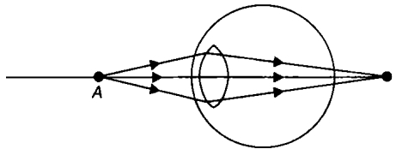  - The focal length of the eye lens is too long.  - The eyeball becomes too small.  - The focal length of the eye lens is too small.  - The eyeball becomes too long.  a) Only (i) and (iv)  b) Only (i) and (ii)  c) Only (iii) and (iv)  d) Only (ii) and (iii) | [1]
41 | Bees are sensitive to:  a) Infrared light  b) All of these  c) ultraviolet light  d) White light | [1]
42 | The coloured light that refracts most while passing through a prism is:  a) Red  b) Blue  c) Yellow  d) Violet | [1]
43 | The change in the focal length of an eye lens in human beings is caused by the action of  a) ciliary muscles  b) optic nerves  c) retina  d) cornea | [1]
44 | Which of the following colours is least scattered by fog, dust or smoke?  a) Blue  b) Yellow  c) Red  d) Violet | [1]
45 | Which of the following statement(s) is/are correct regarding scattering of light?  - Scattering is responsible for the bluish appearance of the sky.  - Clouds having droplets of water scatter all wavelengths almost equal and so are generally white.  - Advanced sunrise and delayed sunset are due to atmospheric reflection.  a) Only (ii) and (iii)  b) Only (iii)  c) Only (i) and (ii)  d) (i), (ii) and (iii) | [1]
46 | The clear sky appears blue because  a) Violet and blue lights get scattered more than lights of all other colours by the atmosphere.  b) Blue light gets absorbed in the atmosphere.  c) Light of all other colours is scattered more than the violet and blue colour lights by the atmosphere.  d) Ultraviolet radiations are absorbed in the atmosphere. | [1]
47 | The sky appears dark to passengers flying at very high altitudes mainly because:  a) the size of molecules is smaller than the wavelength of visible light.  b) scattering of light is not enough at such heights.  c) there is no atmosphere at great heights.  d) the light gets scattered towards the earth. | [1]
48 | The bluish colour of water in deep sea is due to  a) absorption of light by the sea  b) scattering of light  c) reflection of sky in water  d) the presence of algae and other plants found in water | [1]
49 | Phenomenon responsible for the twinkling of stars  a) Atmospheric refraction  b) Internal refraction  c) None of these  d) Regular refraction | [1]
50 | In a room, artificial rain is produced at one end and a strong source of white light is switched on at the other end. To observe the rainbow an observer must  a) Look towards the source  b) Look in a direction equally inclined to the source of raindrops.  c) Look towards the raindrops with the light source behind him  d) Look anywhere in the room | [1]
51 | The image distance from the eye lens in the normal eye when we increase the distance of an object from the eye  a) depends on the size of the eyeball  b) increases  c) remains unchanged  d) decreases | [1]
52 | The danger signals installed at the top of tall buildings are red in colour. These can be easily seen from a distance because among all other colours, the red light.  a) Is scattered the most by smoke or fog  b) Is absorbed the most by smoke or fog  c) Moves fastest in air  d) Is scattered the least by smoke or fog | [1]
53 | The phenomena of light responsible for the working of the human eye is:  a) Reflection  b) Persistence of vision  c) Power of accommodation  d) Refraction | [1]
54 | The part of the eyes refracts light entering the eye from external objects?  a) Lens  b) Pupil  c) Cornea  d) Iris | [1]
55 | Rainbow is a phenomenon due to  a) Combined effect of dispersion, refraction and reflection.  b) Reflection alone  c) Refraction alone  d) Dispersion alone | [1]
56 | What is the observed colour of sky as seen from the moon surface?  a) Black  b) Blue  c) Red  d) None of these. | [1]
57 | The defect of vision in which a person is able to see nearby objects clearly, but not far objects is called:  a) Long - sightedness or Hypermetropia  b) Short - sightedness or myopia  c) Astigmatism  d) Cataract | [1]
58 | Which of the following phenomena contributes significantly to the reddish appearance of the sun at sunrise or sunset?  a) Scattering of light  b) Total internal reflection of light  c) Dispersion of light  d) Reflection of light from the earth | [1]
59 | Light is incident normally on face AB of a prism as shown in figure. A liquid of refractive index p is placed on face AC of the prism. The prism is made of glass of refractive index$\frac{3}{2}$ . The limitsof $μ$ for which total internal reflection takes place on face AC is 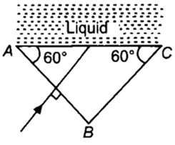  a) $\begin{matrix}μ >\sqrt{3}\end{matrix}$  b) $\begin{matrix}μ >\frac{3\sqrt{3}}{2}\end{matrix}$  c) $\begin{matrix}μ <\frac{3\sqrt{3}}{8}\end{matrix}$  d) $\begin{matrix}μ <\frac{3\sqrt{3}}{4}\end{matrix}$ | [1]
60 | The wavelength corresponding to violet, yellow & red light are$\lambda v,\lambda y{\mathrm}$ and $λr$ respectively.  a) $\begin{matrix}λv <λy <λr\end{matrix}$  b) $\begin{matrix}λv >λy >λr\end{matrix}$  c) $\begin{matrix}λy <λr <λv\end{matrix}$  d) $\begin{matrix}λy <λv <λr\end{matrix}$ | [1]
61 | The image formed by the retina of the human eye is:  a) Real and erect  b) Virtual and inverted  c) Virtual and erect  d) Real and inverted | [1]
62 | The deviation in the path of ray of light can be produced  a) By a glass prism but not by rectangular glass slab.  b) By a glass prism as well as a rectangular glass slab.  c) By a rectangular glass slab but not by a glass prism.  d) Neither by a glass prism nor by rectangular glass slab. | [1]
 | Section C
63 | Draw a ray diagram showing the path of rays of light when it enters with oblique incidence:  - from air to water  - from water to air | [2]
64 | How are we able to see distant and nearby objects clearly? Which part of eye helps in changing curvature of lens? Why no image is formed at blind spot? | [2]
65 | A student cannot see clearly a chart hanging on a wall placed at a distance 3 m from his eye.  - Name the defect of vision he is suffering from.  - Draw a ray diagram to illustrate this defect.  - List its two possible causes. | [2]
66 | Write the conditions for observing a rainbow. Show, by drawing a suitable diagram, how one understands the formationof a rainbow? | [2]
67 | Under what conditions in an arrangement of two plane mirrors, incident ray and reflected ray will always be parallelto each other, whatever may be the angle of incidence. Show thesame with the help of a diagram. | [2]
68 | If you were driving a car, what type of mirror would you prefer to use for observing traffic at your back and why? | [2]
69 | When the object is placed between 2F$​_{1}$ and F $​_{1}$ , what is the position, nature, and size of the image formed? | [2]
70 | The far point of a myopic person is 80 cm in front of the eye. What is the nature and power of the lens required to correct the problem? | [2]
71 | Student sitting at the back bench in a class is not able to see what is written on the blackboard. He, however, sees it clearly when sitting on the front seat at an approximate distance of 1.5 m from the blackboard. Draw ray diagrams to illustrate the image formation of the blackboard when he is seated at the  - back seat  - front seat. | [2]
72 | State reasons to explain these observations.  - Our eye is more sensitive to yellow colour but even then danger signals are red in colour.  - Violet colour is seen at the bottom of the spectrumwhen light is displaced by a prism. | [2]
73 | Draw the given diagram and complete the ray path after passing through the lens 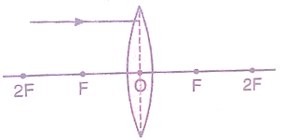 | [2]
74 | Name the factors on which brightness of image in a cameradepends and how? | [2]
75 | A person with myopic eye cannot see objects beyond 1.2metre distinctly. What should be the nature of corrective lenses to restore proper vision? | [2]

